Quant Class 2 - Numbers : Remainders

https://www.facebook.com/events/147809575936068/

1. Basic Divisibility. If you are thorough with it, like this post.

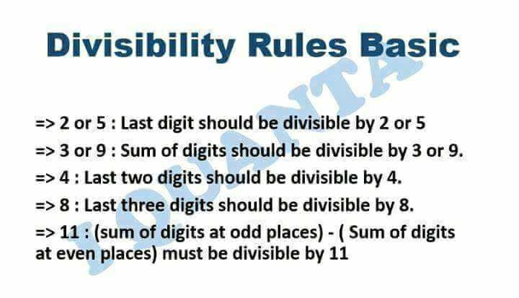

2. Not basic but Conceptual. Go through it once . I'll explain the concept behind these in the next post then it will be easy to remember.

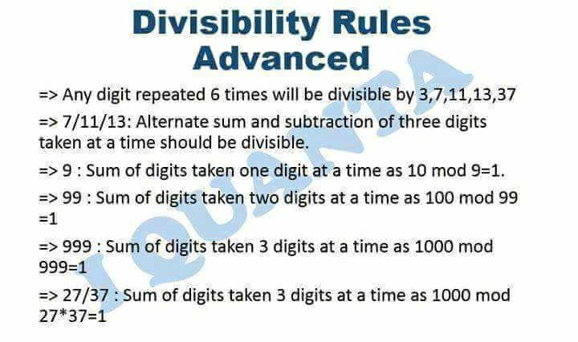

3. [#Concept](https://www.facebook.com/hashtag/concept?source=feed_text&story_id=147834492600243) Not many know it. And if you can understand it fully then you can solve any CAT related divisibility problems . So take your time.

We will discuss moslty these type problems today so dont get panic even if not clear now. After examples erything will get clear

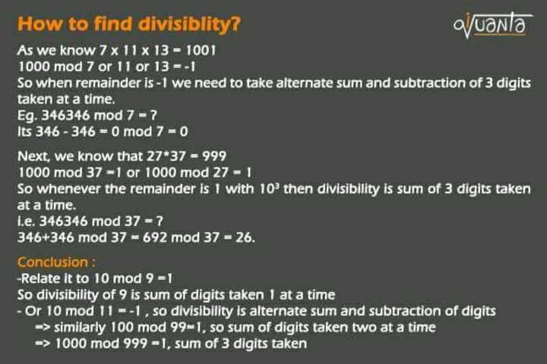

To check divisibility of divisor 999,   
  
We know, 1000 mod 999 =1   
  
●So divisibility of 999 is sum of 3 digits taken at a time .   
  
Now 600 digits means there are 600/3= 200 terms of repeating 364...364...364....  
  
So 364+364+364....200 terms mod 999  
  
364*200 mod 999 = manual divisibility from here.   
  
= 872

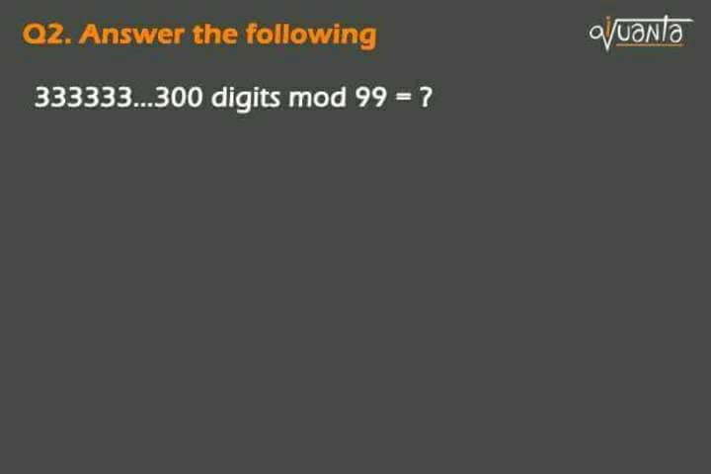

Ab kaise sabka sahi aa rha h ? https://static.xx.fbcdn.net/images/emoji.php/v9/f9f/1/16/1f61b.png:p   
  
Oa : 0  
  
Solution: Divisor is 99  
  
And we know 100 mod 99 = 1   
  
So divisibility of 99 is sum of 2 digits taken at a time .  
  
So 33+33+33+....150 terms   
  
= 33*150 mod 99 = 0

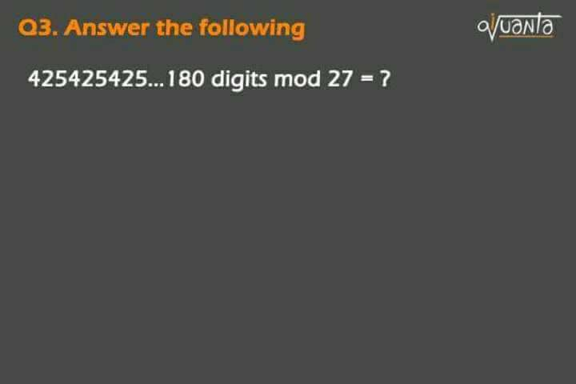

Ans. 12

Oa: 12   
  
Solution :   
  
We know 1000 mod 27 = 1   
  
So divisibility of 27 is sum of digits taken 3 at a time.   
  
=> 425+425+425+...425 (60 terms )  
  
=> 425*60 mod 27 = 12

General Proof for any divisibility. Ex.

● Why is divisibility of 9 as sum of single digits ?

abc mod 9 = a + b + c . why ?

Coz 10 mod 9 = 1

And also 100 mod 9 = 1

So 100a + 10b + c mod 9 = a*1 + b*1 + c = a + b + c.

● Why is divisibility of 11 as alternate sum and subtraction of single digits ?

abc mod 11 = c - b + a

why ? 100a + 10b + c mod 11

100 mod 11 = 1 , and 10 mod 11 = -1

so its a*1 + b*-1 + c = a - b + c

Now similarly it can be generalised for all the numvers like 99, 100 mod 99 = 1 ( sum of two digits)   
or 100 mod 101 = -1 ( altenate sum subtraction)

I derrived it to generalise all the divisibility!!

**so this works only with numbers which leave a remainder of either 1 or -1 when used to divide 10/100/1000.... 10^n**

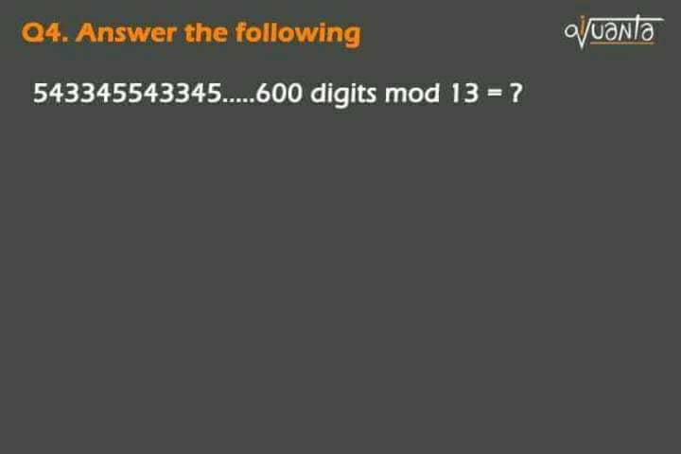

Oa: 12   
  
Divisor is 13   
  
We know 1000 mod 13 = - 1  
  
So divisibility of 13 is alternate sum and subtraction of 3 digits taken at a time.   
  
So 345-543 + 345-543 + ..  
  
= -198*100 mod 13 = -1 = 12   
  
So 12 is the answer. https://static.xx.fbcdn.net/images/emoji.php/v9/f4c/1/16/1f642.png

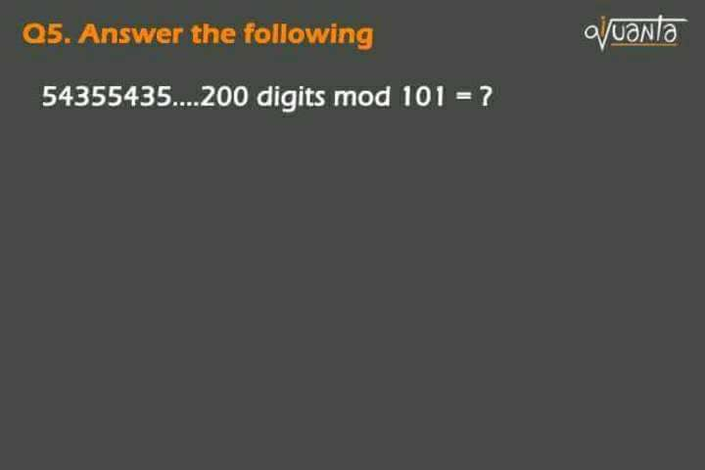

Two ways it can be done  
  
1) ●Divisor => 101   
  
We know 100 mod 101 = -1   
  
So we can apply alternate sum and subtraction of two digits taken at a time.  
  
Ie 35-54 + 35-54...35-54  
  
= -19*50 mod 101 = -41= 60   
---------------------------------  
  
2)●Also as 100 mod 101 = -1   
So 100^2 mod 101 = 1   
ie 10000 mod 101 = 1   
  
As remainder is 1 so we can apply sum of 4 digits taken at a time too.   
  
=> 5435*50 mod 101 = 60

In basic term

Let abcdef mod k = ?

1) If its 1000 mod k = 1

●Then divisibility=> abc + def

2) If its 100 mod k = 1

●Then ab + cd + ef

3) If 1000 mod k = - 1

●Then def - abc

4) If 100 mod k = - 1

●Then its ef - cd + ab

Take 10 mins break .

Samajh aa rha h ?.. Doubt h to puch lo

**Always go right to left.**

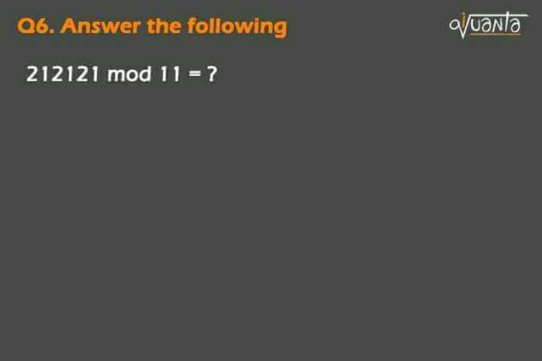

10 mod 11 = - 1   
  
So alternate sum and subtraction of single digits.   
  
So 1-2 + 1-2 + 1-2 = - 3 = 8

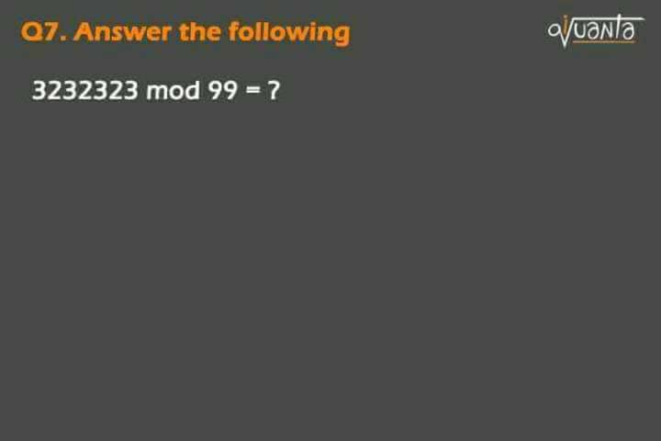

Oa: 72   
  
100 mod 99 = 1   
  
So going from right to left   
  
32 + 32 + 32 +... (3 isn't paired so we can't add it up.)   
  
So first find 32+32+32=96 mod 99= 96  
  
This left out 3 becomes the last digit of the summation of other pairs   
  
So 96"3"...  
  
So 963 mod 99 = 72.

Q. 9.

12312312 mod 7 = ?

**Ans. 123-123 mod 7 = 0. left 12. 12 mod 7 = 5.**

1000 mod 7 =-1   
  
So alternate sum n subtraction of 3 digits  
  
First check 6 digits   
  
123 - 123 = 0   
  
Left with  
  
So 12 mod 7 = 5

Where there is no pairing or triplet formation like last two questiobs, i just keep aside the last terms, to make it complete pair and triplet

And always perform RIGHT to LEFT only.

1. Find the remainder when 123,123,...(upto 300 digits) is divided by 999 and 1001?

2. 75757575.......upto 1500 digits  
Find the remainder divided by 999

3. Find the remainder when 232323....23 (4018 digits) is divided by 999.

4. N=101102103104105.......999   
find the remainder when N is divided by 27 ?

5. 345345345........upto300 digits . what is the remainder when divided by 999??

6. what is the remainder when 987654987654......upto750 digits is divided by 999?

7. 412412412.......900 digits when divided by 999 leaves a remainder of?

8. What is the remainder when 24242424....upto 300 digitd is divided by 999?

1. 312,0 ; 2. 333 ; 3. 991 ; 4. 26 ; 5. 534 ; 6. 330 ; 7. 861 ; 8. 333

:)